Blinkit Analysis

BUSINESS REQUIREMENT

To conduct a comprehensive analysis of Blinkit's sales performance, customer satisfaction, and inventory distribution to identify key insights and opportunities for optimization using various KPIs and visualizations in Power BI.

KPI’s Requirements

1. Total Sales: The overall revenue generated from all items sold.
2. Average Sales: The average revenue per sale.
3. Number of Items: The total count of different items sold.
4. Average Rating: The average customer rating for items sold.

Granular Requirements

1. Total Sales by Fat Content:

Objective: Analyze the impact of fat content on total sales.

Additional KPI Metrics: Assess how other KPIs (Average Sales, Number of Items, Average Rating) vary with fat content.

2. Total Sales by Item Type:

Objective: Identify the performance of different item types in terms of total sales.

Additional KPI Metrics: Assess how other KPIs (Average Sales, Number of Items, Average Rating) vary with fat content.

3. Fat Content by Outlet for Total Sales:

Objective: Compare total sales across different outlets segmented by fat content.

Additional KPI Metrics: Assess how other KPIs (Average Sales, Number of Items, Average Rating) vary with fat content.

4. Total Sales by Outlet Establishment:

Objective: Evaluate how the age or type of outlet establishment influences total sales.

Chart’s Requirements

5. Percentage of Sales by Outlet Size:

Objective: Analyze the correlation between outlet size and total sales.

6. Sales by Outlet Location:

Objective: Assess the geographic distribution of sales across different locations.

7. All Metrics by Outlet Type:

Objective: Provide a comprehensive view of all key metrics (Total Sales, Average Sales, Number of Items, Average Rating) broken down by different outlet types.

Data Processing

* See all the data imported:

SELECT * FROM blinkitdata

* DATA CLEANING:

Cleaning the Item_Fat_Content field ensures data consistency and accuracy in analysis. The presence of multiple variations of the same category (e.g., LF, low fat vs. Low Fat) can cause issues in reporting, aggregations, and filtering. By standardizing these values, we improve data quality, making it easier to generate insights and maintain uniformity in our datasets.

UPDATE blinkitdata

SET Item_Fat_Content =

CASE

WHEN Item_Fat_Content IN ('LF', 'low fat') THEN 'Low Fat'

WHEN Item_Fat_Content = 'reg' THEN 'Regular'

ELSE Item_Fat_Content

END;

After executing this query check the data has been cleaned or not using below query

SELECT DISTINCT Item_Fat_Content FROM blinkitdata;

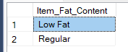

Exploratory Data analysis

A. KPI’s

1. TOTAL SALES:

SELECT CAST(SUM(Total_Sales) / 1000000.0 AS DECIMAL(10,2)) AS Total_Sales_Million

FROM blinkitdata;

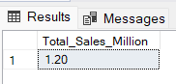

2. AVERAGE SALES

SELECT CAST(AVG(Total_Sales) AS INT) AS Avg_Sales

FROM blinkitdata;

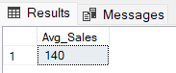

3. NO OF ITEMS

SELECT COUNT(*) AS No_of_Orders

FROM blinkitdata;

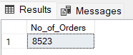

4. AVG RATING

SELECT CAST(AVG(Rating) AS DECIMAL(10,1)) AS Avg_Rating

FROM blinkitdata;

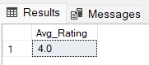

B. Total Sales by Fat Content:

SELECT Item_Fat_Content, CAST(SUM(Total_Sales) AS DECIMAL(10,2)) AS Total_Sales

FROM blinkitdata

GROUP BY Item_Fat_Content

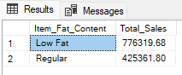

C. Total Sales by Item Type

SELECT Item_Type, CAST(SUM(Total_Sales) AS DECIMAL(10,2)) AS Total_Sales

FROM blinkitdata

GROUP BY Item_Type

ORDER BY Total_Sales DESC

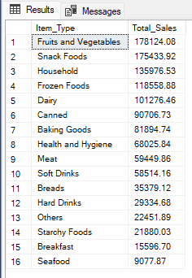

D. Fat Content by Outlet for Total Sales

SELECT Outlet_Location_Type,

ISNULL([Low Fat], 0) AS Low_Fat,

ISNULL([Regular], 0) AS Regular

FROM

(

SELECT Outlet_Location_Type, Item_Fat_Content,

CAST(SUM(Total_Sales) AS DECIMAL(10,2)) AS Total_Sales

FROM blinkitdata

GROUP BY Outlet_Location_Type, Item_Fat_Content

) AS SourceTable

PIVOT

(

SUM(Total_Sales)

FOR Item_Fat_Content IN ([Low Fat], [Regular])

) AS PivotTable

ORDER BY Outlet_Location_Type;

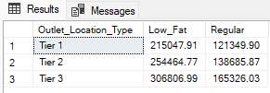

E. Total Sales by Outlet Establishment

SELECT Outlet_Establishment_Year, CAST(SUM(Total_Sales) AS DECIMAL(10,2)) AS Total_Sales

FROM blinkitdata

GROUP BY Outlet_Establishment_Year

ORDER BY Outlet_Establishment_Year

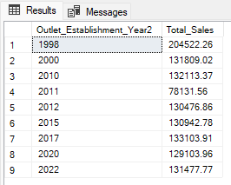

F. Percentage of Sales by Outlet Size

SELECT

Outlet_Size,

CAST(SUM(Total_Sales) AS DECIMAL(10,2)) AS Total_Sales,

CAST((SUM(Total_Sales) * 100.0 / SUM(SUM(Total_Sales)) OVER()) AS DECIMAL(10,2)) AS Sales_Percentage

FROM blinkitdata

GROUP BY Outlet_Size

ORDER BY Total_Sales DESC;

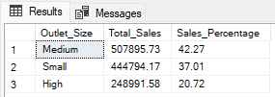

G. Sales by Outlet Location

SELECT Outlet_Location_Type, CAST(SUM(Total_Sales) AS DECIMAL(10,2)) AS Total_Sales

FROM blinkitdata

GROUP BY Outlet_Location_Type

ORDER BY Total_Sales DESC

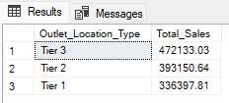

H. All Metrics by Outlet Type:

SELECT Outlet_Type,

CAST(SUM(Total_Sales) AS DECIMAL(10,2)) AS Total_Sales,

CAST(AVG(Total_Sales) AS DECIMAL(10,0)) AS Avg_Sales,

COUNT(*) AS No_Of_Items,

CAST(AVG(Rating) AS DECIMAL(10,2)) AS Avg_Rating,

CAST(AVG(Item_Visibility) AS DECIMAL(10,2)) AS Item_Visibility

FROM blinkitdata

GROUP BY Outlet_Type

ORDER BY Total_Sales DESC

